<https://www.c-sharpcorner.com/article/jwt-json-web-token-authentication-in-asp-net-core/>

Install-Package Microsoft.AspNetCore.Authentication.JwtBearer -Version 3.0.0



C:\Temp\VueNew\ToDoWith LoginAPI2\ToDoWithLoginAPI\ToDoWithLoginAPI\Startup.cs

        public void ConfigureServices(IServiceCollection services)

    {

        services.AddAuthentication(JwtBearerDefaults.AuthenticationScheme)

.AddJwtBearer(options =>

{

    options.TokenValidationParameters = new TokenValidationParameters

    {

        ValidateIssuer = true,

        ValidateAudience = true,

        ValidateLifetime = true,

        ValidateIssuerSigningKey = true,

        ValidIssuer = Configuration["Jwt:Issuer"],

        ValidAudience = Configuration["Jwt:Issuer"],

        IssuerSigningKey = new SymmetricSecurityKey(Encoding.UTF8.GetBytes(Configuration["Jwt:Key"]))

    };

});

        services.AddDbContext<ToDoWithLoginAPIContext>();

        services.AddControllers();

    }

C:\Temp\VueNew\ToDoWith LoginAPI2\ToDoWithLoginAPI\ToDoWithLoginAPI\appsettings.json

"Jwt": {

  "Key": "ThisismySecretKey",

  "Issuer": "Test.com"

}

C:\Temp\VueNew\ToDoWith LoginAPI2\ToDoWithLoginAPI\ToDoWithLoginAPI\Startup.cs

public void Configure(IApplicationBuilder app, IWebHostEnvironment env)

{

    app.UseAuthentication();

    if (env.IsDevelopment())

    {

        app.UseDeveloperExceptionPage();

    }

    app.UseRouting();

    app.UseAuthorization();

    app.UseEndpoints(endpoints =>

    {

        endpoints.MapControllers();

    });

}

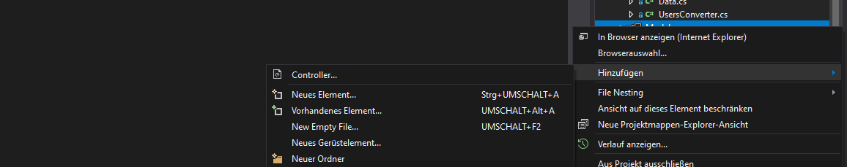

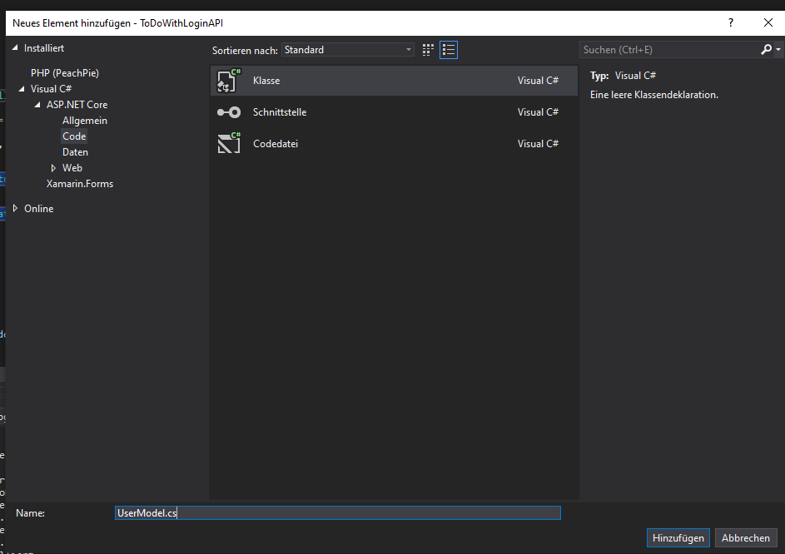

public class UserModel

{

    public string Username { get; set; }

    public string Password { get; set; }

    public string EmailAddress { get; set; }

    public DateTime DateOfJoing { get; set; }

}

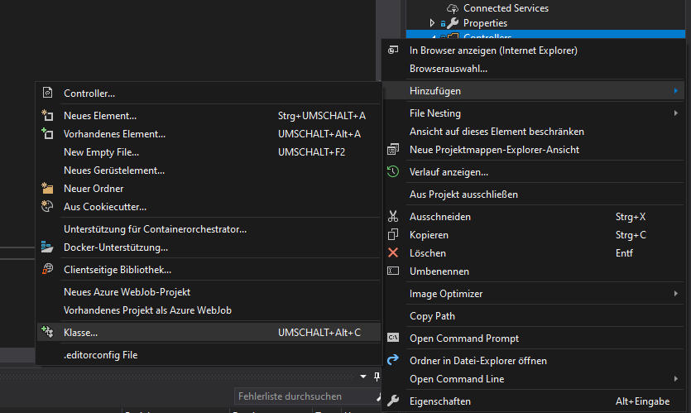

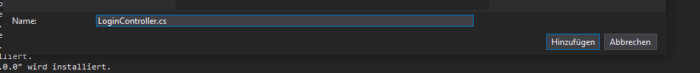

C:\Temp\VueNew\ToDoWith LoginAPI2\ToDoWithLoginAPI\ToDoWithLoginAPI\Controllers\WeatherForecastController.cs

[HttpGet]

[Authorize]

public IEnumerable<WeatherForecast> Get()

